



**SCHOOL OF ELECTRICAL AND ELECTRONIC ENGINEERING**

Bachelor of Engineering (Hons) BE in Elect/Cont/Comm/Comp Eng

**Energy Efficiency**

**Names**

Vanesa Sorecau (C18319666)

Talha Tallat (D18124645)

Alessio Persechini (C17414882)

**Course Module**

Energy Resources and Eng. Thermodynamics

**Supervisor**

Colm Murray

**Submission Date**

24th October 2021

**Table of Contents**

Table of Figures 4

List of Tables 4

Introduction 5

1. Energy Efficiency in Transport 6

1.1 Vehicle Efficiency 8

1.2 Economics of Energy Efficiency in Transport 8

1.2.1. Overview of Trends in Public Transport Expenditure and Utilisation 10

1.3 Effect on Climate Change 11

1.3.1. Energy-saving in transportation 12

2. Energy Efficiency in Buildings 13

2.1 Climate Change & Improving Energy Efficiency in buildings 13

2.1.1 Building Envelope Insulation (Thermal Insulation) 13

2.1.2 Air Tightness 14

2.1.3 Ventilation 14

2.2 Building Regulations – Energy Efficiency 15

2.4 Economics of Energy Efficiency in Buildings & COVID 16

2.4.1 Facts on Economics of Energy Efficiency in Buildings in Ireland (seai) 16

3.1 Case Study: Aurivo’s Donegal Dairy Plant 17

3.2 Case Study: TG4 18

4.0 Report on Public Sector Energy Efficiency Performance 18

Conclusion 21

References 22

# **Table of Figures**

Figure 1 - Types of transportation where energy is consumed [9] 5

Figure 2 - Final energy by mode of transport [6] 6

Figure 3 - Transport largest energy users [7] 6

Figure 4 - Transport final energy use by fuel [10] 8

Figure 5 - Trends in public transport capital and current expenditure from 2008 to 2020 [11] 9

Figure 6 - PSO passenger Journeys by operator 2018 [11] 9

Figure 7 - Trends in total PSO Passenger journeys, 2012-2018 [11] 10

Figure 8 - Saint-Gobain Isover System - Insulation of the Envelope [1] 13

Figure 9 - Policy Coverage of total final energy consumption in buildings, 2000-2018 [4] 15

Figure 10 - Energy performance of departmental groups 18

Figure 11 - Departmental performance against 2020 target (1) 19

Figure 12 - Departmental performance against 2020 target (2) 19

# **List of Tables**

Table 1 - Growth rates, quantities and shares of final consumption in transport [10] 8

# **Introduction**

Energy efficiency is the process of using less energy to perform the same task which eliminates energy waste. Energy efficiency brings a variety of benefits including reducing Co2 emissions, reducing demand for energy imports, and lowering energy costs on a household and economy wide level. Improving energy efficiency is the cheapest and most immediate way to reduce the use of fossil fuels. Every area of the economy, whether it is buildings, transportation, industry, or energy generation, has great prospects for efficiency improvements to save on costs and to reduce their carbon footprint.

In Ireland, Transport is one of the biggest consumers of energy, accounting for 18% in 2019 and buildings also account for some 41% of global energy savings potential by 2035. Therefore, in this report we will discuss the energy efficiency progress in the transport field, in building and building regulations and two case studies are discussed that show the advantaged of changing to higher efficient systems. Lastly the Report on Public Sector Energy Efficiency Performance is discussed which shows the progress of public sector energy efficiency.

# **1. Energy Efficiency in Transport**

Energy efficiency in transport is transportation systems that are designed to provide a reduction of energy consumed in moving passengers, goods by road, rail, air, water, pipeline, and energy used in freight transportation moving fuels used by large trucks, freight trains or any other energy consumed in moving any type of load.



Figure 1 - Types of transportation where energy is consumed [9]

The driving behavior is that the largest potential contribution to fuel efficiency, across nearly all vehicle types, is idle reduction. When the engine of a car is running (idling) for long periods wastes fuel and poses a health risk to people in and around the vehicle. As an example, a typical idling bus diesel engine burns about half a gallon of fuel per hour. Vehicle diesel engines are generally tuned for optimum operation at travelling speeds so that they combust fuel less efficiently when idling.

Idling leads to more pollutants per gallon and these pollutants are concentrated in one place because the vehicle is stationary. These are typically places where people, like vulnerable school children, are gathered. Diesel exhaust contains particles that lodge in lung tissue when inhaled and is believed to cause or exacerbate various health problems, including asthma, cancer, reduced lung function, and premature death.

According to the SEAI, transport is the largest source of final energy demand in Ireland. In 2018 it accounted for 42% of final energy demand and grew by 2.6%.[6]

Figure 2 - Final energy by mode of transport [6]

**Private cars**

Private cars are the transport mode with the largest energy use. They accounted for 40% of transport final energy demand in 2018. [6]

**Aviation and HGV**

Energy used for air travel increased by 7.9% in 2018, surpassing the previous peak set in 2007 for the first time. Aviation now accounts for 21% of the energy used for transport, second only to private cars. Heavy Goods Vehicle (HGV) freight was the next largest use of transport energy at 14%. Energy use for HGV freight and aviation has been the most sensitive to changes in the economy.[6]

**Buses, coaches, and rail**

Public and private bus or coach transport accounted for less than 3% of transport energy use in 2018. Rail accounted for less than 1%.[6]

Figure 3 - Transport largest energy users [7]

# **Vehicle Efficiency**

Energy-efficient vehicles such as plug-in hybrids require less fuel to cover a given distance. Which generates hardly any emissions and makes them less expensive to operate. Fully electric vehicles are way more fuel-efficient and demand for EVs has raised due to the cost of lithium-ion batteries significantly dropping over the last decade.

Electricity is required to achieve desired cutting in oil consumption and greenhouse gas emissions and electric motors have a significant advantage over gasoline combustion engines in reducing fuel costs and greenhouse gas emissions.

Hybrid “plug-in” gasoline-electric vehicles that can be charged from the electric grid could lead the trend toward a new generation of partial and all-electric vehicles.

At current Ireland retail electric rate ranging from € 0.24 - 0.30 per kilowatt-hour and fuelling a passenger vehicle with electricity would cost the equivalent of €15 per gallon of gasoline, charging an average EV from flat to full. An average Irish EV owner will pay €4.97 in electricity costs for every 100km travelled.

All Electric Vehicles (AEV) are way more efficient than conventional gas-powered vehicles. For example, AEV batteries convert 59 to 62 % of energy into vehicle movement while gas-powered vehicles only convert between 17 and 21%.

More efficient vehicles that run on lower carbon-emitting fuels are critical to meeting energy security and climate protection goals. EESI promotes improvements in vehicle fuel economy while working to accelerate a transition from petroleum-based fuels to other liquid and non-liquid “fuels” derived from renewable sources.[8]

# **Economics of Energy Efficiency in Transport**

According to the Energy in Ireland 2019 report, which stats that the overall energy used in transport increased by 2.6% in 2018 compared with the previous year. As the economy started to expand again, transport energy use grew. It expanded every year after 2013, and in 2018 it was 25% higher than in 2012.

* Petrol use continued to fall in 2018, reducing by 9.2% to 821 ktoe. Petrol consumption is now 56% lower than the peak in 2007 and accounts for 16% of transport energy use. [10]
* Diesel consumption grew by 4.7% during 2018, to 3,095 ktoe. Diesel has by far the largest share of transport fuel use, accounting for 60% in 2018. [10]
* Jet kerosene consumption increased by 7.9% in 2018, to 1,102 ktoe, accounting for 21% of transport's final energy use, the second-largest fuel share after diesel. [10]

Figure 4 - Transport final energy use by fuel [10]

Figure 4 and Table 1 shows the trends in transport's final energy use split by fuel type between 2005 and 2018. Over the period 2005 - 2018, the biggest shift in the transport market was from petrol to diesel. While consumption of diesel increased by 30%, petrol use fell by 55%. [10]

Table 1 - Growth rates, quantities and shares of final consumption in transport [10]

Diesel’s overall market share grew from 47% in 2005 to 60% in 2018. Transport's energy use peaked in 2007, at 5,715 ktoe, and fell each year thereafter, until 2013. As the economy started to expand again, transport's energy use grew. It expanded every year after 2013, and in 2018 it was 25% higher than in 2012. Energy consumption in transport was 2.3% higher in 2018 than in 2005 but remained 9% lower than the peak in 2007. [10]

### **1.2.1. Overview of Trends in Public Transport Expenditure and Utilisation**

According to the public policy research, demand for public transport increased substantially during the economic recovery (2012-2018). Figure 5 shows the number of passenger journeys carried by individual operators. Since 2012, the total number of PSO passenger journeys increased substantially from 210m in 2012 to 269m in 2018, representing an increase of almost 60m or 28% in 2012.

Dublin Bus experienced the biggest rise in total PSO passenger numbers at over 140m in 2018, increasing by almost 27m from 113m in 2012. In terms of light and heavy rail services, Luas Passenger journeys increased by 12.5m, while Iarnróid Éireann PSO passenger journeys rose by 11m during these years. Of all the main PSO service operators, Bus Éireann had the lowest increase in total passenger journeys at almost 7m, increasing from 28.6m in 2012 to 35.2m in 2018. Other PSO services (i.e. LocalLink and Private operators) increased by almost 2m during these years.[11]

Figure 5 - Trends in public transport capital and current expenditure from 2008 to 2020 [11]

Figure 6 - PSO passenger Journeys by operator 2018 [11]

Approximately 269 million passenger journeys were carried in 2018 on Public Service Obligation Services (PSO). These are bus and rail services that are socially necessary and are provided as a public good heavily subsidised by exchequer funding. The three main objectives of the PSO programme are to:

* Provide transport services that are socially beneficial but financially unviable.
* Encourage modal shift and public transport use through higher service provision and lower fares.
* Increase accessibility and social equity (Department of Transport Tourism and Sport, 2019b, p. 10). [11]

Figure 7 - Trends in total PSO Passenger journeys, 2012-2018 [11]

# **1.3 Effect on Climate Change**

Transportation has a big negative impact on climate change due to **burning fossil fuels** like gasoline and diesel which releases carbon dioxide (CO2), a greenhouse gas, into the atmosphere. The buildup of CO2 and other greenhouse gases like methane (CH4), nitrous oxide (N2O), and hydrofluorocarbons (HFCs) is causing the Earth’s atmosphere to warm, resulting in changes to the climate we are already starting to see today.

Energy & CO2 intensity of passenger and freight transport has not improved during the past three decades. Freight transport, trucks consume significantly more energy per tonne-km than rail or ship transport. Rail is the **most energy-efficient** mode of passenger transport. Whereas improvements during the 1970s, aviation continues to be the least efficient mode.

# **1.3.1. Energy-saving in transportation**

* Avoid using private vehicles extensively and instead, try to use public transportation whenever possible.
* Removing extra unwanted weight in the car like a flat tyre, unwanted luggage in the vehicle, especially heavy ones, can reduce the vehicle’s mileage. The reduction is based on the percentage of extra weight (relative to the vehicle’s weight) and affects smaller vehicles more than the bigger ones.
* Keep automobiles fuel filters clean and save fuel.
* Don't forget to keep your vehicle tuned up. When a vehicle is running well, it uses nine per cent less fuel and thus emits fewer toxic and noxious fumes.
* Avoid using a clutch pedal as a footrest.
* It is more fuel-efficient to restart your car beyond 1 minute
* Maintain recommended tyre pressure. [12]

# **2. Energy Efficiency in Buildings**

Energy efficient buildings are buildings that are designed to provide a reduction of energy need for space heating, cooling, ventilating, lighting, cooking, water heating, refrigerating, and operating electric and mechanical devices. One-third of global energy is consumed in buildings. These can be residential, public, and commercial buildings. Energy use in buildings is growing globally as cities in developing countries continue to develop and become more modern.

Because of their high energy consumption, buildings offer exceptional opportunities for energy savings. From researching the International Energy Agency, we found out that buildings account for some 41 % of global energy savings potential by 2035, compared with the industrial sector which is 24 % and the transport sector which is 21 %.

# **2.1 Climate Change & Improving Energy Efficiency in buildings**

Heating and cooling buildings uses a lot of energy. Producing this energy requires us to burn fossil fuels like coal and oil, which contributes to air pollution and generates large amounts of greenhouse gases that contribute to climate change. As buildings are renovated or repairs are made to save energy or increase comfort, indoor air quality problems can be created. Leaky dwellings will also result in higher CO2 emissions and indoor pollutants like radon, mold, particles, and chemicals from a variety of sources can build up to unhealthy levels that affect climate change. Energy related CO2 emissions from buildings have risen in recent years after flattening between 2013 and 2016. Direct and indirect emissions from electricity and commercial heat used in buildings rose to 10 GtCO2 in 2019, the highest level ever recorded.

We can improve energy efficiency in buildings by reducing heating, cooling, ventilating, and lighting loads for new buildings or when renovating existing buildings. This can be done by applying local climate-sensitive passive design techniques, such as building form, orientation, surface color, sun shading, building envelope insulation, air tightness and ventilation. Building envelope insulation, air tightness and ventilation are described below.

## **2.1.1 Building Envelope Insulation (Thermal Insulation)**

These energy efficient buildings can be achieved by thermal insulation. Thermal insulation is low-cost and widely available. It saves energy and money and reduces emissions the moment it is installed. Insulation is as relevant in cold regions as in hot ones. In cold regions, insulation keeps a building warm and limits the need of energy for heating, whereas in hot regions the same insulation systems keep the heat out and reduce the need for air conditioning. Overall, it makes a building more energy efficient and saves a lot of time and money as it has two functions.

## **2.1.2 Air Tightness**

Air tightness reduces leakage which is the uncontrolled flow of air through gaps and cracks in the construction of buildings. Air leakages need to be reduced as much as possible in order to create efficient, controllable, comfortable, healthy and durable buildings. Saint-Gobain Isover has developed systems with innovative accessories that allow appropriate installation of the insulation while guaranteeing excellent air tightness and allowing proper moisture management.  You can see a visual description in Figure 8 below.

Figure 8 - Saint-Gobain Isover System - Insulation of the Envelope [1]

## **2.1.3 Ventilation**

Ventilation is the intended and controlled ingress and egress of air through buildings, delivering fresh air, and exhausting stale air through purpose-built ventilators in combination with the designed heating system and humidity control, and the fabric of the building itself. If you do not insulate properly and ventilate too little, you can risk warm humid air condensing on cold, poorly insulated surfaces which will create moisture that allows for molds and fungi to grow. A controlled ventilation strategy will satisfy the fresh air requirements of an airtight building and make the building more energy efficient.

# **2.2 Building Regulations – Energy Efficiency**

There are many EU & Irish Directives and Regulations when it comes to building more energy efficient buildings. Below you can see some examples of Building Regulations.

1. **The EU Directive of legislation related to the renovation of buildings**​:

The EU directive for the renovation of buildings is the *‘EU Energy Performance of Buildings Directive (EPBD) (Directive (EU) 2018/844)’*. It is from 2018 and it needs to be followed by everyone.

1. **Ventilation in Buildings**

The *‘S.I. No. 263/2019 – Building Regulations (Part F Amendment) Regulations 2019’* states that adequate and effective means of ventilation must be provided for people in buildings by limiting the moisture content of the air within the buildings so that it doe does not contribute to condensation and mold growth and also by limiting the concentration of harmful pollutants in the air within the building.

1. **Conservation of Fuel and Energy – Buildings other than Dwellings (Part L)**

*‘SI’ 538 of 2017 – Building Regulations (Part L Amendment) Regulations 2017’*

**L1:** A building shall be designed and constructed to ensure that the energy performance of the building is such as to limit the amount of energy required for the operation of the building and the amount of carbon dioxide emissions associated with this energy use.

**L4:** For existing buildings other than dwellings, the requirements of L1 can be met by limiting heat loss, proving energy efficiency space heating, and cooling systems and ensuring that the building is appropriately designed to limit need for cooling.

1. **Solar energy & Solar panels to improve energy efficiency:**

* If you wish to add a solar panel to the roof of your home to make it more energy efficient, building regulations approval is likely to be needed.
* The adequacy of the existing roof to carry the load (weight) from the panel will need to be checked and proven.

# **2.4 Economics of Energy Efficiency in Buildings & COVID**

Energy efficiency investments are still not keeping pace with construction. Total investments in the global buildings sector were an estimated USD 5.7 trillion in 2019. More than 60% of these investments were for building construction, while the rest were energy related.

In 2019, incremental spending on energy efficiency investments amounted to over USD 150 billion. After progress in the last three years, 2019 incremental spending increased around 2% from the previous year.

* Policy coverage continues to expand, although at slower rate than in 2018. Energy efficiency policy coverage for buildings continued to advance in 2018. About 35% of energy use in buildings was covered by policies in 2018, only a slight improvement from the 34% coverage in 2017. You can see the graph below in Figure 9.

Figure 9 - Policy Coverage of total final energy consumption in buildings, 2000-2018 [4]

## **2.4.1 Facts on** **Economics of Energy Efficiency in Buildings in Ireland (seai)**

* Power showers are one of the top five energy users in the home. By reducing your shower time by 5 minutes you could save around €50 per year.
* A typical household could save around €50 per year just by plugging out their appliances.
* Irish homes account for over a quarter (25%) of our total energy use, even more than industry.
* Lowering your room temperature by 1⁰C can reduce your energy bill by 10%.

# **3.1 Case Study: Aurivo’s Donegal Dairy Plant**

Aurivo Consumer Foods produces a range of milk and real butter products and has been in operation since the 1980s.The company manufactures 120 million litres of milk each year for consumers all around Ireland.

The company decided to look at how they could make its Donegal factory more energy efficient in 2015, with the help of The Sustainable Energy Authority of Ireland (SEAI). The project covered all electrical and thermal energy consumption at Aurivo Consumer Foods dairy plant in Killygordon for the separation, pasteurisation, homogenization, and storage of bulk liquid milk and cream. They had to first gather information, measure energy use, and determine what improvements they could make. The team examined its pasteurisation process with the purpose of lowering the plant's thermal loads.

Previously for heating, an oil-fired steam boiler was employed, and an electric chiller was used for cooling. The waste heat from the pasteurisation process was rejected by the electric chiller. Before the waste heat is rejected, the new process collects it. This waste heat is used to power a new heat pump system that is designed to produce the necessary heat for pasteurisation of milk. Aurivo is the first factory in Ireland to employ 80-degree heat pump-generated water.

The project resulted in the construction of a new modern processing plant that included pasteurisation, separation, and standardization, as well as heating provided by a heat pump that was integrated with the refrigeration system.

Excellence in Energy Efficiency Design (EXEED) certification was an important milestone in the development of Aurivo's Energy Management System, with the goal of achieving EXEED certification for all future significant energy management projects.

EXEED allows businesses to take a systematic approach to the design, building, and commissioning of new assets and modifications to existing assets. The goal of the EXEED Certified program is to influence and provide new energy efficient design management best practices. At the early phases of the lifecycle, EXEED creates, tests, and controls optimum energy performance and management. The SEAI provide an EXEED grant program is worth up to €1,000,000 per project every year for companies of any size. Organizations can employ EXEED as a catalyst to encourage innovation throughout a production process, which can result in additional non-energy benefits. [17]

The results of this energy efficient project are that the dairy plant has made a substantial contribution to the environment, decreasing carbon emissions by 80%, which amounts to 780 tonnes annually and cutting electricity consumption by 8% on site. This project has cut the amount of oil used in this procedure by almost 85%. The plant is the first in Ireland to use heat pump generated water at 80 degrees. This project achieved a certificate for EXEED design, and all round resulted in €347,000 in annual cost savings. [13]

# **3.2 Case Study: TG4**

An Energy Management System helps TG4 control their energy consumption on a daily basis. Energy management has been integrated with energy efficiency projects and renewable energy technologies as part of TG4's proactive commitment to ensuring its energy effect on the environment is minimal.

TG4 completed a substantial lighting upgrade project in 2019. A total of 571 standard CFL and halogen spotlight fittings were replaced with LEDs. This renovation resulted in a total yearly energy savings of 148,000 kWh, or a 68%reduction in energy use. The company has avoided around 60,000 kg of CO2 emissions per year by implementing these measures.

The director of technology at TG4 stated that TG4 and their SEAI partners are delighted with the savings in power and carbon footprint reduction resulting from the building wide LED lighting retrofit project. TG4 is fully committed to playing its part in achieving the targets set out in the Climate Action Plan.

TG4 has stated that starting from January 2021, all programmes commissioned by the broadcaster will be required to utilize the albert carbon calculator to track their carbon footprint. The calculator was first used at the BBC in the United Kingdom in 2011 and was updated for use in Ireland in 2019. Its goal is to help production businesses understand their work's environmental impact and, as a result, lessen their carbon footprint. TG4 is the first Irish broadcaster to introduce this as a mandatory requirement. [14]

# **4.0 Report on Public Sector Energy Efficiency Performance**

SEAI's seventh annual report on Public Sector Energy Efficiency Performance has been issued for the Department of Environment, Climate and Communications (DECC). It is set in the context of Ireland's EU and national commitments, as well as global climate change targets, whereby all Irish public bodies (as defined in SI 426 of 2014) must reach a target of 33% energy efficiency improvement by the end of 2020.

Public bodies are required to report annual energy efficiency data to the SEAI which manages the reporting process on behalf of the Department of Environment, Climate and Communications.

Overall public sector energy efficiency gains have reached 29% in 2019, according to the data, indicating three years of significant improvement since the Public Sector Energy Efficiency Strategy was implemented.

The report analyses data given by organizations on annual energy consumption, energy and carbon savings achieved, and energy efficiency performance in 2019 in comparison to 2020 targets. Thousands of projects, ranging from structured energy management to building and facility modifications, retrofits, changes in transportation, better energy procurement, and behavioural change in organizations, are being implemented to achieve energy efficiency gains.

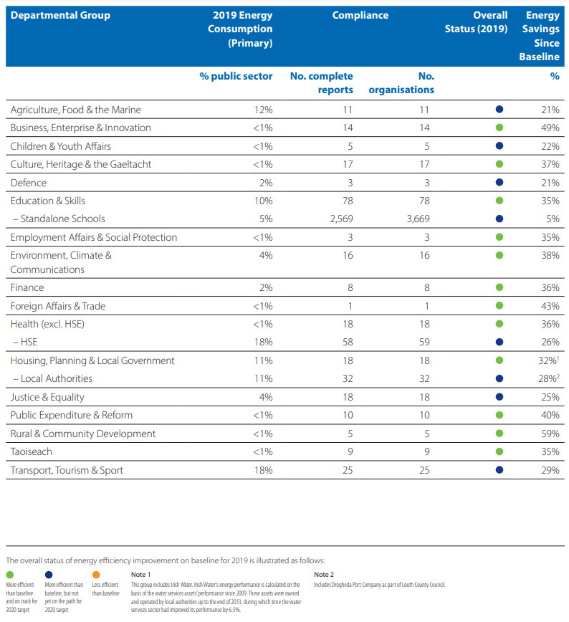

Figure 10 - Energy performance of departmental groups

Figure 10 shows the efficiency performance and energy use by departmental group by the end of 2019, as well as the number of public bodies in each group and their reporting status. The consumption and efficiency data displayed are the totals of all individual public bodies within each Departmental Group, including the governing Department.

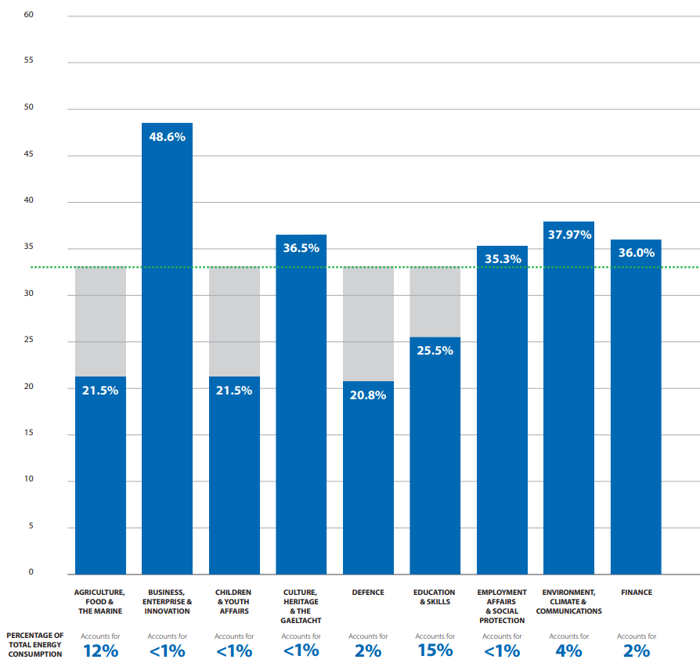

Figure 11 - Departmental performance against 2020 target (1)

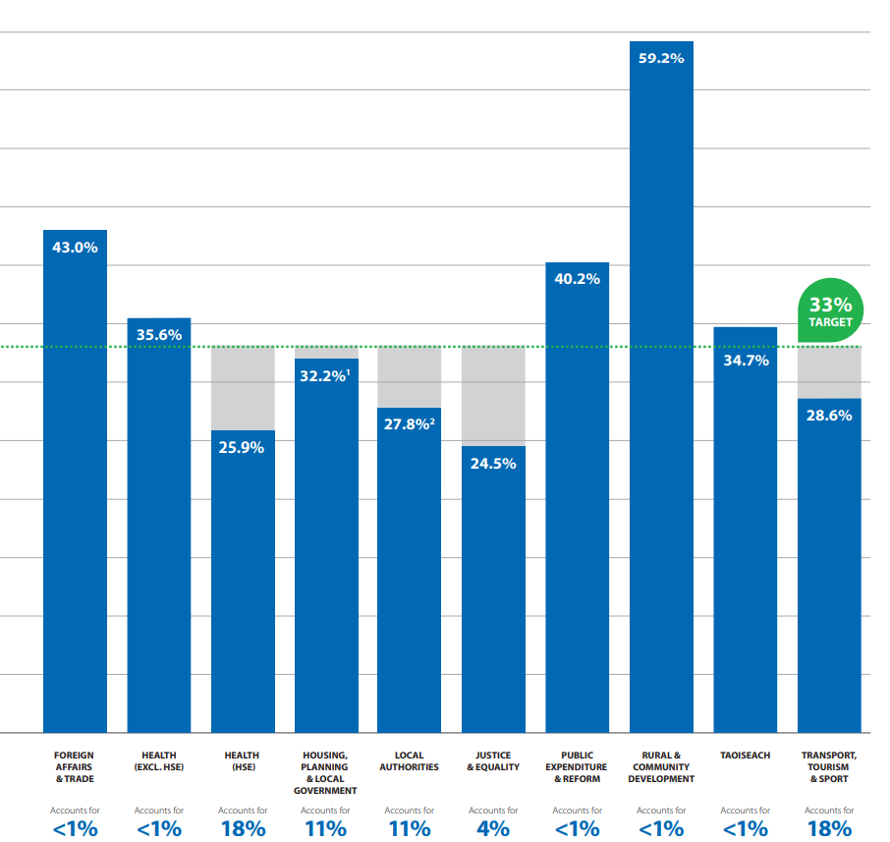

Figure 12 - Departmental performance against 2020 target (2)

According to the data from the public bodies, annual energy efficiency gains in 2019 represent a 29% total efficiency increase. The online national energy monitoring and reporting (M&R) system was established by SEAI and DECC to report their annual energy performance data for any organization to use. Despite the fact that a 29% efficiency gain constitutes significant savings, public bodies must close the gap to the 2020 target, as well as the new 50% target for 2030. [15]

# **Conclusion**

* The energy-efficient transportation organisations can provide the travelling public with more energy-efficient choices for getting around is a very important strategy to cut back oil consumption and greenhouse gas emissions that might improve the efficiency and resiliency of our transportation systems. Public transportation (including buses, ferries, subways, and commuter rail), walking, and biking enable people to drive less, save money, and, in many cases, save time and stay healthy.
* Buildings are a very big part of our lives, and we use energy every day by creating and using these buildings. We need to make sure that these building are energy efficient for a better future. This can be done by reducing heating, cooling, ventilating, and lighting loads for new buildings or when renovating existing buildings. This can be done by applying local climate-sensitive passive design techniques, such as building form, orientation, surface color, sun shading, building envelope insulation, air tightness and ventilation. We also learned that energy efficiency investments are still not keeping pace with construction, and this means that there needs to be improvement in the economic side of energy efficiency in buildings.
* The case studies discussed show that when organisations take the step towards making their workspace more energy efficient using measures such as upgrading lighting, heating, building fabric and structured energy management improvements, it will reduce annual energy costs. With the help from the EXEED grant scheme, public bodies should be more inclined to implement energy efficient measures to increase savings, reduce carbon emissions and reduce fossil fuel consumption. The Annual Report 2020 on Public Sector Energy Efficiency Performance shows that energy efficiency was increased by 29%, 4% less than the 2020 goal. While the overall level of project reporting is increasing, many efficiency improvements are still on a small scale, as seen from the figures 11 and 12, the departments that have a higher percentage of total energy consumption have not met the 33% target. Although the goal was not met, there has been an increase in energy efficiency from previous years, showing steady progress.

# **References**

1. Isover, “Renewable Energy Directive”. [Online]. Available: https://www.isover.com/how-design-and-build-energy-efficient-building [Accessed: 20 - Oct- 2020].
2. ESMAP, “Improving Energy Efficiency in Buildings”. [Online]. Available: https://openknowledge.worldbank.org/bitstream/handle/10986/21306/936750NWP0Box30ent0MayoralNote02014.pdf?sequence=1 [Accessed: 20 - Oct- 2020].
3. Planning Portal, “Building Regulations: Energy Efficiency”. [Online]. Available: https://www.planningportal.co.uk/info/200130/common_projects/17/extensions/8 [Accessed: 20 - Oct- 2020].
4. iea, “Tracking Buildings 2020”. [Online]. Available: https://www.iea.org/reports/tracking-buildings-2020 [Accessed: 21 - Oct- 2020].
5. iea, “Tracking Buildings 2020”. [Online]. Available: https://www.seai.ie/home-energy/building-energy-rating-ber/ [Accessed: 21 - Oct- 2020].
6. seai.ie. 2021. “Transport”. [online] Available at: <https://www.seai.ie/data-and-insights/seai-statistics/key-statistics/transport/#comp00005b3f76b80000006f4a2ac1> [Accessed 23 October 2021].
7. "Energy in Ireland", seai.ie, 2021. [Online]. Available: https://www.seai.ie/publications/Energy-in-Ireland-2019-.pdf. [Accessed: 23- Oct- 2021]
8. (EESI), "Vehicle Efficiency | EESI", Eesi.org, 2021. [Online]. Available: https://www.eesi.org/topics/vehicle-efficiency/description. [Accessed: 23- Oct- 2021]
9. "Nanotechnology and the Transportation Industry", AZoNano.com, 2021. [Online]. Available: https://www.azonano.com/article.aspx?ArticleID=595. [Accessed: 23- Oct- 2021]
10. "Energy in Ireland | Transport", seai.ie, 2021. [Online]. Available: https://www.seai.ie/publications/Energy-in-Ireland-2019-.pdf. [Accessed: 23- Oct- 2021]
11. P. Malone, "The Utility of Public Transport in Ireland: Post COVID-19 Lockdown and Beyond | Public Policy", Publicpolicy.ie, 2021. [Online]. Available: https://publicpolicy.ie/papers/the-utility-of-public-transport-in-ireland-post-covid-19-lockdown-and-beyond/. [Accessed: 23- Oct- 2021]
12. "vikaspedia Domains", Vikaspedia.in, 2021. [Online]. Available: https://www.vikaspedia.in/energy/energy-conservation/energy-conservation-in-transport-sector/energy-conservation-in-transport-systems. [Accessed: 23- Oct- 2021]
13. "Donegal dairy plant cuts costs by €347,000", seai.ie, 2021. [Online]. Available: https://www.seai.ie/case-studies/dairy-plant-cuts-costs/. [Accessed: 19- Oct- 2021].
14. "Energy efficiency at TG4", seai.ie, 2021. [Online]. Available: https://www.seai.ie/case-studies/energy-efficiency-at-tg4/. [Accessed: 17- Oct- 2021].
15. "Annual Report 2020 on Public Sector Energy Efficiency Performance", seai.ie, 2021. [Online]. Available: https://www.seai.ie/publications/Public-Sector-Annual-Report-2020.pdf. [Accessed: 19- Oct- 2021].
16. Gov.ie, “Building Requlations”. [Online]. Available: tps://www.irishstatutebook.ie/eli/2019/si/263/made/en/print [Accessed: 21 - Oct- 2020].
17. "EXEED Certified Grant", seai.ie, 2021. [Online]. Available: https://www.seai.ie/business-and-public-sector/business-grants-and-supports/exeed-certified-grant/. [Accessed: 20- Oct- 2021].